EX 8 IMAGE GENERATION USING VARIATIONAL AUTOENCODER (VAE)
DATE:
Problem Statement:
Implement a Variational Autoencoder (VAE) to generate new images from a given dataset. Train the model to learn the latent representation of images and generate new samples from the learned distribution.
Suggested Dataset: CelebA Dataset
Objectives:
- Understand the concept of generative models using latent space representations.
- Implement encoder-decoder architecture with reparameterization.
- Train a VAE on CelebA and generate new human face images.
- Visualize generated samples from the latent space.
Scope:
VAEs are probabilistic generative models capable of learning latent representations and generating realistic samples. This experiment explores the VAE pipeline—encoding, sampling via reparameterization, and decoding—to generate new samples that resemble the training distribution.
Tools and Libraries Used:
- Python 3.x
- PyTorch
- torchvision
- matplotlib
- CelebA Dataset

Implementation Steps:
Step 1: Import Required Libraries

import torch import torch.nn as nn import torch.nn.functional as F import torchvision
from torchvision import datasets, transforms from torch.utils.data import DataLoader, Subset import matplotlib.pyplot as plt

Step 2: Configure Parameters and Load Dataset

device = torch.device('cuda' if torch.cuda.is_available() else 'cpu')

image_size = 64 batch_size = 128 latent_dim = 100 num_epochs = 5
learning_rate = 1e-3

transform = transforms.Compose([ transforms.CenterCrop(178), transforms.Resize(image_size), transforms.ToTensor(),
transforms.Normalize((0.5, 0.5, 0.5), (0.5, 0.5, 0.5))
])

dataset = datasets.CelebA(root='data', split='train', download=True, transform=transform) dataset = Subset(dataset, range(500)) # Limit to 500 samples for speed dataloader = DataLoader(dataset, batch_size=batch_size, shuffle=True)

Step 3: Define Encoder Network

class Encoder(nn.Module): def __init__(self, latent_dim): super(Encoder, self).__init__() self.conv = nn.Sequential(
nn.Conv2d(3, 64, 4, 2, 1), nn.ReLU(), nn.Conv2d(64, 128, 4, 2, 1), nn.BatchNorm2d(128), nn.ReLU(), nn.Conv2d(128, 256, 4, 2, 1), nn.BatchNorm2d(256), nn.ReLU(), nn.Conv2d(256, 512, 4, 2, 1), nn.BatchNorm2d(512), nn.ReLU()
)
self.fc_mu = nn.Linear(512*4*4, latent_dim) self.fc_logvar = nn.Linear(512*4*4, latent_dim)

def forward(self, x): x = self.conv(x) x = x.view(x.size(0), -1)
return self.fc_mu(x), self.fc_logvar(x)

Step 4: Define Decoder Network

class Decoder(nn.Module): def __init__(self, latent_dim): super(Decoder, self).__init__() self.fc = nn.Linear(latent_dim, 512*4*4) self.deconv = nn.Sequential( nn.ConvTranspose2d(512, 256, 4, 2, 1), nn.BatchNorm2d(256), nn.ReLU(), nn.ConvTranspose2d(256, 128, 4, 2, 1), nn.BatchNorm2d(128), nn.ReLU(), nn.ConvTranspose2d(128, 64, 4, 2, 1), nn.BatchNorm2d(64), nn.ReLU(), nn.ConvTranspose2d(64, 3, 4, 2, 1), nn.Tanh()
)

def forward(self, z):
x = self.fc(z)
x = x.view(x.size(0), 512, 4, 4)
return self.deconv(x)

Step 5: Define the VAE Model

class VAE(nn.Module): def __init__(self, latent_dim): super(VAE, self).__init__() self.encoder = Encoder(latent_dim) self.decoder = Decoder(latent_dim)

def reparameterize(self, mu, logvar):
std = torch.exp(0.5 * logvar) eps = torch.randn_like(std)
return mu + eps * std

def forward(self, x): mu, logvar = self.encoder(x) z = self.reparameterize(mu, logvar)
return self.decoder(z), mu, logvar

Step 6: Define Loss Function

def vae_loss(recon_x, x, mu, logvar): recon_loss = F.mse_loss(recon_x, x, reduction='sum') kl_div = -0.5 * torch.sum(1 + logvar - mu.pow(2) - logvar.exp()) return recon_loss + kl_div

Step 7: Train the Model and Generate Images

model = VAE(latent_dim).to(device)
optimizer = torch.optim.Adam(model.parameters(), lr=learning_rate)

for epoch in range(num_epochs):
model.train() total_loss = 0 for images, _ in dataloader: images = images.to(device) recon, mu, logvar = model(images) loss = vae_loss(recon, images, mu, logvar)

optimizer.zero_grad() loss.backward()
optimizer.step()

total_loss += loss.item()

print(f"Epoch [{epoch+1}/{num_epochs}], Loss:
{total_loss/len(dataloader.dataset):.4f}")

# Generate and visualize samples
model.eval() with torch.no_grad(): z = torch.randn(64, latent_dim).to(device)
sample_images = model.decoder(z).cpu() * 0.5 + 0.5 # De-normalize grid = torchvision.utils.make_grid(sample_images, nrow=8) plt.imshow(grid.permute(1, 2, 0)) plt.axis('off')
plt.title(f"Generated Faces - Epoch {epoch+1}") plt.show()

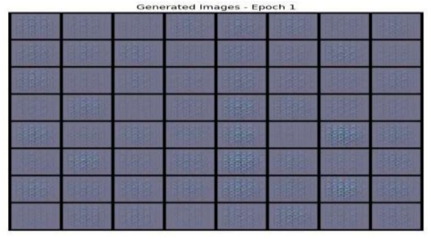
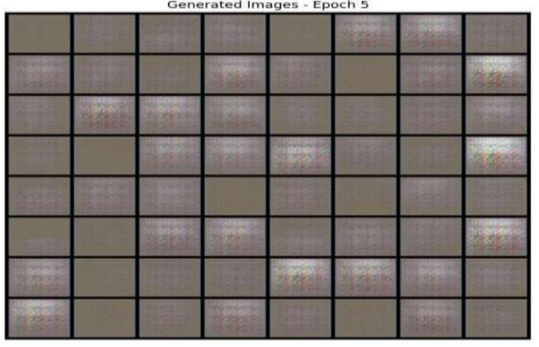

Conclusion:
In this experiment, a Variational Autoencoder was implemented and trained on a subset of the CelebA dataset. The model effectively learned to encode facial features into a latent space and generate realistic synthetic faces from random samples in that space. This showcases the generative power of deep neural architectures.

